4th International Colloquium Energy and Environmental Protection

Title of the Paper
Ionescu Paul^{a*}, Popescu Ion^{b}, Georgescu Mihaiª
ª Petroleum-Gas University of Ploieşti, Romania
^{b} Politehnica University of Bucharest, Romania
* Corresponding author: paul.ionescu@upg-ploiesti.ro

Use this example to format your abstract. The abstract (maximum 500 words) should be written in English including figures, tables and references.
The accepted abstract will be published in 4th International Colloquium Energy and Environmental Protection Book of Abstracts with ISBN and will be distributed to participants to the conference.
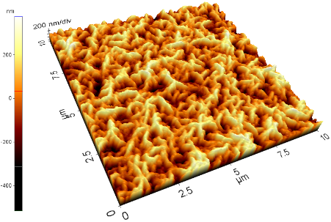
Fig. 1. Title of the figure

Table 1. Title of the table
Sample | Diameter, nm |  |  | G-band/D-band
Co-MCM-41 | 1.65 | 1.01 | 0.91 | 1.11

References
- Bong, M., & Clark, R. E. (1999). Comparison between self-concept and self-efficacy in academic motivation research. Educational Psychologist, 34(3), 139-153.
- Byrne, B. M. (1984). The general/academic self-concept nomological network: A review of construct validation research. Review of Educational Research, 54, 427-456.

